PERTH MODERN SCHOOL


UNIT 3C/3D MAS – 2012

TEST 1 – POLAR COORDINATES & COMPLEX NUMBERS

NAME: SOLUTIONS DATE: 14/15 February 2012

[To achieve full marks, working and reasoning should be shown.]
[A maximum of 2 marks will be deducted for incorrect rounding, units, notation, etc.]

This is Resource Free – 40 minutes for 36 marks:

1. [2, 2, 2 = 6 marks]
Determine 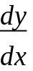 for each of the following

a) y = (e^{2x} + 1)³
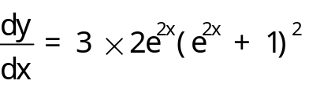 ✓
= 6e^{2x}(e^{2x} + 1)² ✓

b) y = 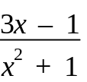
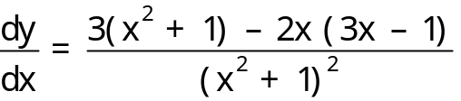 ✓
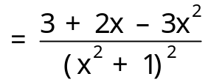 ✓

c) y = ln[x²(x + 1)]
y = 2 ln x + ln(x + 1) ✓
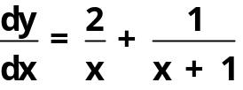 ✓
2. [4 marks]
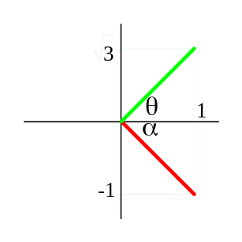 Express (1, -1) and (1, 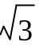) into exact polar form for -π < θ ≤ π.

r₁ = 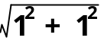 = 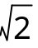 ✓
α = tan⁻¹ 1 = ⇒ θ₁ =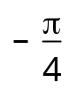 ✓
∴ (1, –1) = [, ] -1 overall if omit this line or not [].
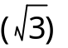
r₂ = 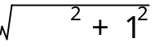 = 2 ✓
θ = tan⁻¹ 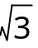 = ✓
∴ (1, ) = [2, ]

3. [2 marks]
Find the exact distance between the points A [6, 25⁰] and B [10, 145⁰].

AB = 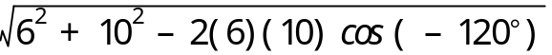 ✓
= 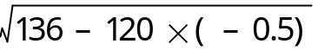
= 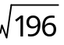
= 14 units ✓

- [3 marks]
Find the polar equation and the Cartesian equation of a circle of centre (0,0) and radius 3.

Polar equation: r = 3 ✓

Cartesian equation: 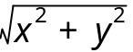 = 3 ✓
⇒ x² + y² = 9 ✓

5. [1, 2, 2 = 5 marks]
Given z = 3 – 3i, calculate:
- = 3 + 3i ✓

- z ² = (3 – 3i)(3 – 3i)
= 9 – 9i – 9i – 9
= -18i ✓

- 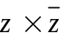 = (3 – 3i)(3 + 3i) ✓
= 9 + 9i – 9i + 9
= 18 ✓

6. [1, 1, 1 = 3 marks]
For each of the following, express p in terms of q.
a) q⁴ = 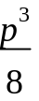
p³ = 8q⁴
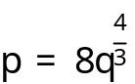 ✓

b) log_{e} p = 2 log_{e} q
log_{e} p = log_{e} q²
p = q² ✓

c) 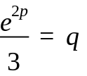
e^{2p} = 3q
2p = ln 3q
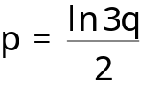 ✓

- [3 marks]
The Cartesian equation of a circle is x² + y² = 10. Find the polar equation of this circle.

x² + y² = 10 ⇒ circle centre (0,0) and radius 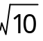 ✓✓
∴ Polar equation is r = . ✓
8. [1, 4, 2 = 7 marks]
If z = cis and w = cis ,
a) express 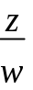 in polar form,
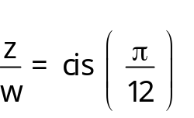 ✓ -1 overall if given as co-ordinates in [].

b) express z, w and in Cartesian form, and

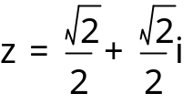 ✓ or 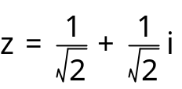
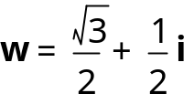 ✓
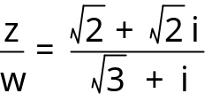 ✓✓

c) give with a rationalised denominator.

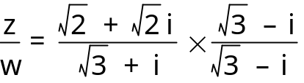 ✓
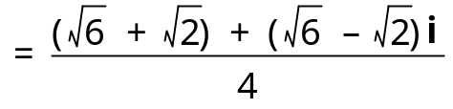 ✓

- [3 marks]
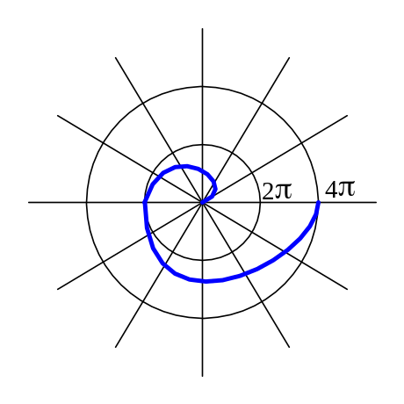Find the polar equation of this curve.

Equation is in the form r = kθ.
First x-intercept is [2π,π]. ✓
⇒ k = 2 ✓
∴ Polar equation is r = 2θ. ✓

